B. In-Depth Explanation & Analysis
1. Order vs. Molecularity This is the most frequent "distinguish between" question.
- Order: Determined experimentally. Can be 0, fraction, or integer. Applicable to complex (multi-step) reactions.
- Molecularity: Determined theoretically from the mechanism. Must be an integer ( $1,2,3$ ). Applicable only to elementary (single-step) reactions. Molecularity > 3 is rare because the probability of $4$ molecules colliding simultaneously is negligible.
2. Units of Rate Constant ( $k$ ) The unit of $k$ tells you the order of the reaction instantly.
- General Formula: ${\left(mol⋅L^{-1}\right)}^{1-n}⋅s^{-1}$
- Zero Order $(n=0)$ : $mol⋅L^{-1}⋅s^{-1}$ (Same as Rate).
- First Order $(n=1)$ : $s^{-1}$ (Time inverse).
- Second Order $(n=2):L⋅mol^{-1}⋅s^{-1}$.
3. Activation Energy & Catalysts
- Activation Energy ( $E_{a}$ ): The extra energy required by reactant molecules to cross the energy barrier and form the activated complex.
- Catalyst: It provides an alternative pathway with a lower Activation Energy ( $E_{a}^{'}$ ). It does not change $ΔG$ (Gibbs Energy) or equilibrium constant ( $K$ ), only the speed ( $k$ ).
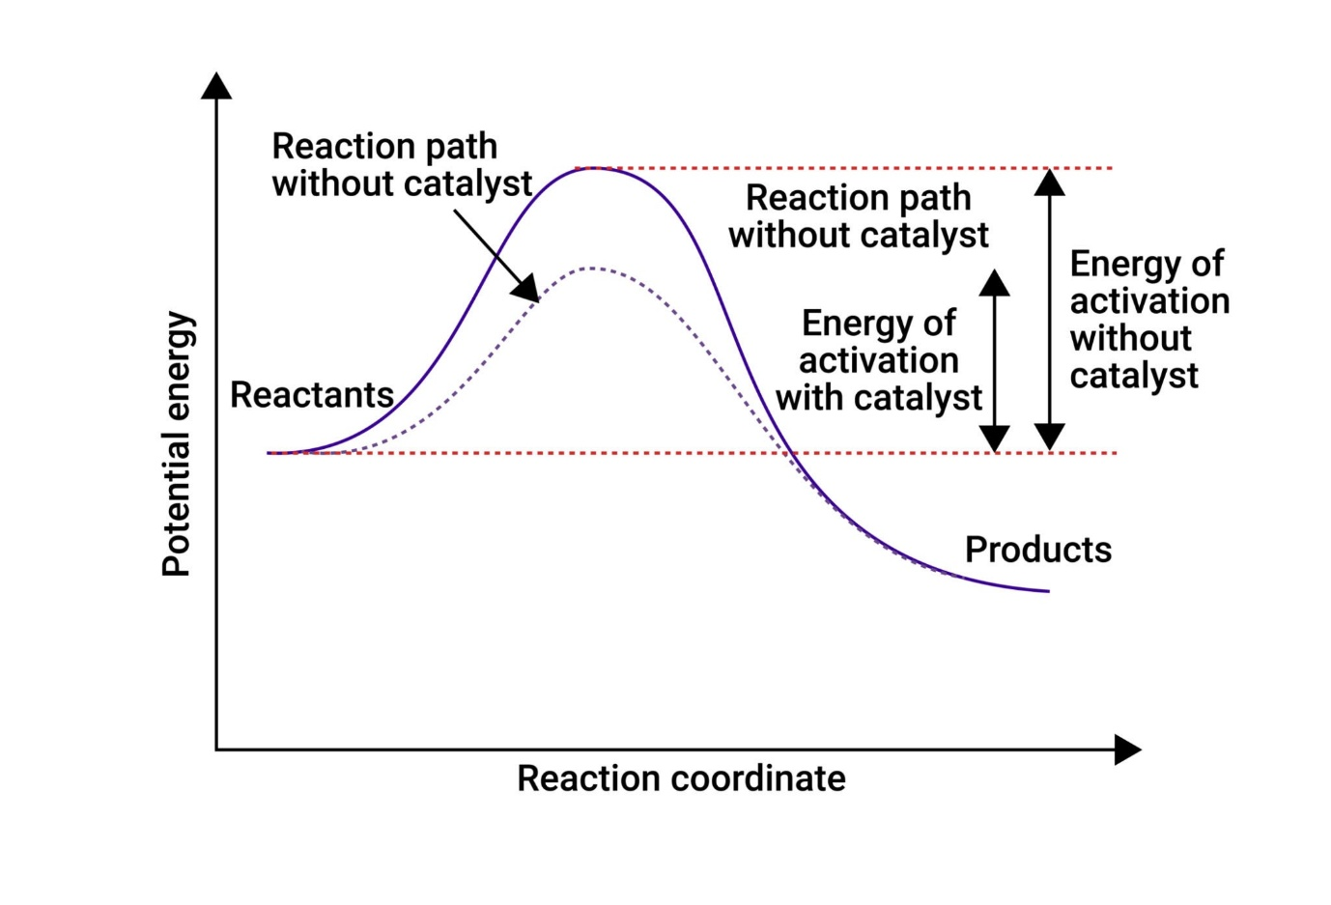
4. Pseudo-First Order Reaction Sometimes a reaction looks second order (e.g., Hydrolysis of Ester: Rate $=k[$ Ester $][$ Water $]$ ), but because water is in huge excess, its concentration doesn't practically change. The rate depends only on the ester, making it Pseudo-First Order.

